FOR IMMEDIATE RELEASE
February 29, 2008
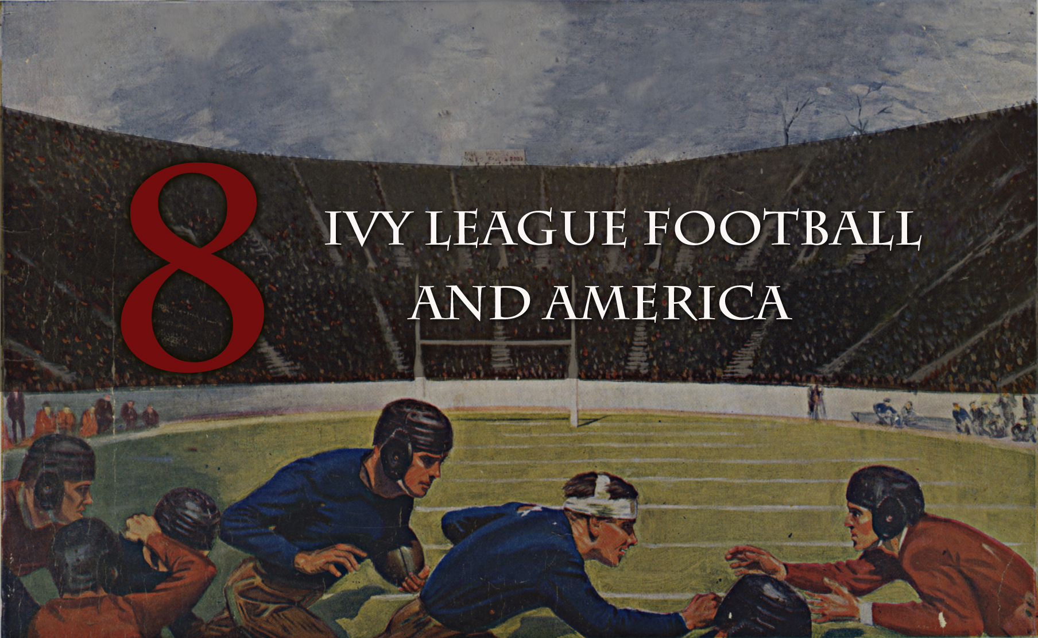

ORIGINAL DOCUMENTARY FILM ABOUT IVY LEAGUE FOOTBALL NOW COMPLETED

For Love & Honor Productions is proud to announce the completion of Eight: Ivy League Football and America, an original feature-length documentary film (TRT 96 minutes).
A world premiere, hosted by the Ivy Football Association, will be held on Thursday, April 24, 2008 at the Yale Club in New York City.
Eight, which tells the history of Ivy League football from its earliest days to the present, is narrated by two-time Tony Award-winning actor Brian Dennehy (Columbia ’60). It also features interviews with Academy Award-winning actor Tommy Lee Jones (Harvard ’69), Penn State Coach Joe Paterno (Brown ’50), ESPN anchor Chris Berman (Brown ’77), General Electric CEO Jeff Immelt (Dartmouth ’78), former Secretary of State George Shultz (Princeton ’42), College and Pro Football Hall of Famer Chuck Bednarik (Penn ‘49), four-time Pro Bowl running back Calvin Hill (Yale ’69), Chicago Bears standout lineman Dan Jiggetts (Harvard ’76), Heisman Trophy winner Dick Kazmaier (Princeton ’52), actor and Heisman Trophy runner-up Ed Marinaro (Cornell ’72), Intuit Chairman Bill Campbell (Columbia ‘62), and many others.
From the game’s rough and chaotic beginnings, Ivy League schools have built American football, produced some its most enduring and inspirational figures, and embodied what intercollegiate athletics can be at their best. At the core of Ivy League football are the values and leadership lessons transmitted to the men who play it. These men have continued to teach and lead the country based on their experiences both on the gridiron and in the classroom. They are the student-athletes who thrilled America when they played, and who continue to excel today. Eight: Ivy League Football and America is their story.
The film is directed by Erik Greenberg Anjou (A Cantor’s Tale: Ergo Media and the cool surface: Columbia TriStar) and produced by Mr. Anjou and Mark F. Bernstein (author of Football: The Ivy League Origins of an American Obsession: University of Pennsylvania Press, 2001). It was edited by Karlyn Michelson (Anti-Semitism in the 21st Century: The Resurgence and A Cantor’s Tale) and features an original score by Grammy-nominated guitarist Gary Lucas (Gods and Monsters).
Further details regarding the film’s premiere and distribution platform will be posted on its website: www.forloveandhonorfilm.com.
To learn more about the documentary, please contact Erik Anjou at 917.691.0270 or Mark F. Bernstein at 215.848.1999; or email forloveandhonorfilm@gmail.com.

